40.58: a) At the turning points 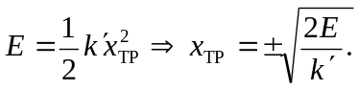
b) 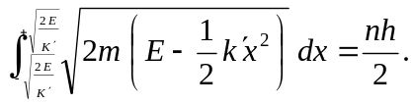
To evaluate the integral, we want to get it into a form that matches the standard integral given.
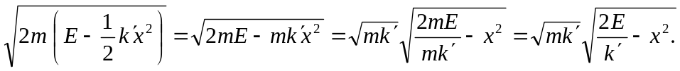
Letting 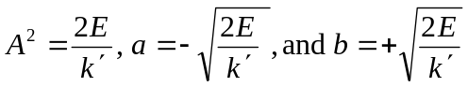
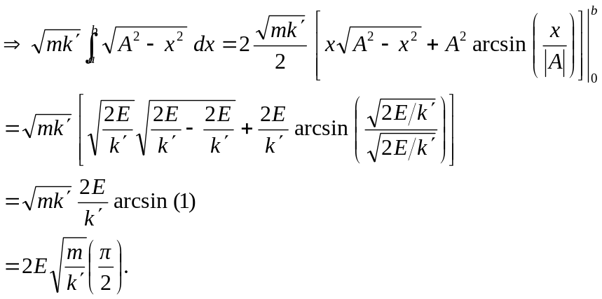
Using WKB, this is equal to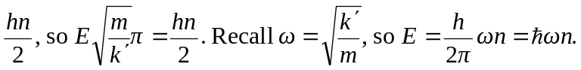
c) We are missing the zero-point-energy offset of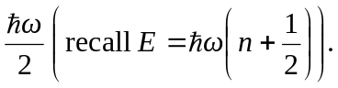
However, our approximation isn’t bad at all!

